Scholarship Proposal

for



by

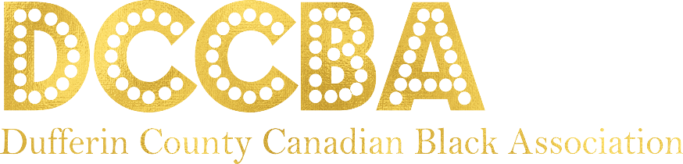

Prepared by:

**Alethia O’Hara-Stephenson, CIP, MBA**

President, Dufferin County Canadian Black Association (DCCBA)

718 Halbert Drive,

Shelburne, ON L9V 2S5

[Alethia@dufferincountycba.org](mailto:Alethia@dufferincountycba.org)

(647) 210-1939

# Introduction

The Dufferin County Canadian Black Association was founded on June 3, 2020 by Shelburne resident Alethia O’Hara Stephenson. The impetus for the creation of the Association followed after many discussions with community members, political leaders and stakeholders about the growing Black population in Dufferin County (Blacks including those of African decedent and individuals from the Caribbean and Latin diaspora) and the need to provide a voice, advocacy, a safe space along with educational programs, support services, community outreach and scholarship opportunities benefiting families and businesses within Dufferin County.

The (DCCBA) is committed to being a true community partner working with other established agencies to bring value to the Dufferin County community. Our Association is inclusive and welcoming to all who wish to volunteer, provide feedback, attend events and sign up for future programs.

***Mission:*** *To provide leadership for the continued development and enhancement of the Black community through civic engagement, education, programs and services and advocate for equity and wellbeing for the Black community in Dufferin County. To be a central hub for resources, tools and programs that are unique to the needs of the Black Community in Dufferin County*

***Vision:*** *To develop and foster a socially and economically equitable group that will continue to contribute to the growth and development in Dufferin County and Canada. To have a strong focus on Youth Achievement and Excellence. To partner with government officials (all levels), local businesses & community organizations to better serve the community.*

***Values:*** *Advocacy Excellence Education Integrity*

# Board Members

The selection of our Board Members was thoughtful and deliberate to set the organization up for success and to solidify its strategic vision and goals.

# Success and Accomplishments to date

* Corporation Registered
* Accounting measures implemented
* Website inclusive of membership, donations, programs and services established.
* Board Members selected
* Partnership established with Dufferin County, Town of Shelburne, Flato, Cariati Law and many more!
* Community donations and government funding

# What we plan to offer

1. Cultural Awareness and Education Programs
2. Financial Literacy Sessions
3. Coding Sessions
4. Job workshops
5. Mentorship sessions
6. Leadership Programs and Volunteer opportunities
7. Annual Scholarships for Post Secondary students

# Partnership Opportunity with Streams Community Hub

DCCBA aims to partner with organizations like Streams that exemplifies a commitment to community building and in particular the development of our youth.

We are inviting Streams Community Hub to Partner with DCCBA by providing an annual scholarship to 1 graduating High School Student or 1 current Post Secondary Student pursuing studies in the Arts with a value of $500.

## Commitment Term (years)

The following table outlines the cost for a 1 to 5-year period for sponsoring a scholarship for 1 graduating student or post secondary student each year attending a Post Secondary Institution in Canada.

|  |  |  |
| --- | --- | --- |
| **Term**  **(Subject to renewal)** | **1 Student/Year** | **Students Impacted** |
| 1 | $500 | 1 |
| 2 | $500 | 1 |
| 3 | $500 | 1 |
| 4 | $500 | 1 |
| 5 | $500 | 1 |

**Impact: Five students over a 5 year period and a total investment of $2500**

# **Scholarship Description**

Sponsored by Streams Community Hub and valued at $500, the Streams Community Hub Arts Scholarship is awarded to a graduating high school or post-secondary student pursuing a major in an arts discipline or program.

**Eligibility Criteria**:

1. Open to all students who are residents of Dufferin County, who identify as Black and who are pursuing studies in the Arts.
2. Applicants must submit a 750 word essay demonstrating how this scholarship will help them.
3. Applicant must provide proof of acceptance into post-secondary institution
4. Applicant must submit a creative arts piece (original video, art, photograph, written work, etc.)

# Benefits of Partnering with Dufferin County Canadian Black Association

1. Feature on the Community Spotlight Page
2. Corporate Logo and website link will be added to our Sponsor and Partner page
3. Scholarship named after organization; “**Streams Community Hub Arts Scholarship”**
4. President (or delegate) sit on the review board for the scholarship applications
5. President (or delegate) present for the scholarship presentation ceremony
6. Award winner photos will be displayed on DCCBA website along with sponsor name

Thank you for your consideration and support. I look forward to hearing from you.

Alethia O’Hara-Stephenson, CIP, BA, MBA

President and Founder of **Dufferin County Canadian Black Association**